**Microsoft azure fundamentals ai**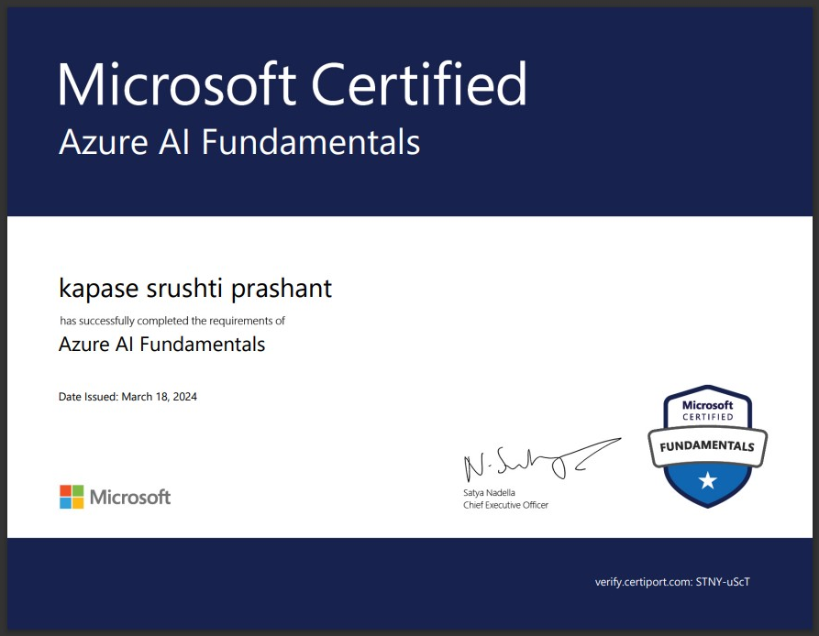

**WEB DEVELOPMENT MERN STACK**

**AI HANDLING  
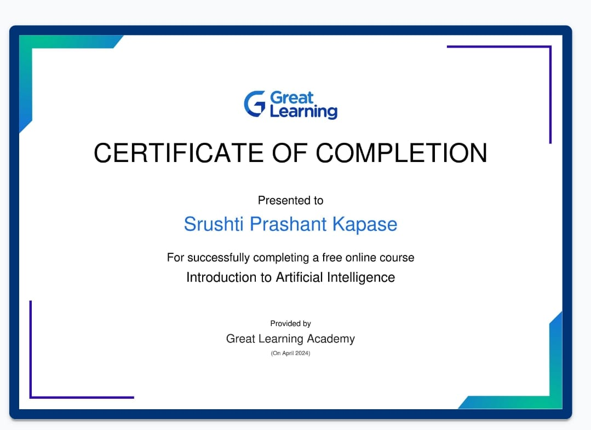  
aws basic+advance(cloud handling)**

